Data Analysis & Visualization

PROJECT REPORT

(Project Semester August-December 2018)

Crime Data Analysis Dashboard

Submitted by
Anshul Sharma
Reg No : 12410160
Program & Section : BTECH CSE(M028)
Course Code : INT 387

Under the Guidance of

(Dr. Tanima Thakur UID: 23532)

Discipline of CSE/IT

Lovely School of Computer Science & Engg.

Lovely Professional University, Phagwara
CERTIFICATE

This is to certify that Anshul Sharma bearing Registration no. 12410160 has completed the INT 387 project titled, “Crime Data Analysis ” under my guidance and supervision. To the best of my knowledge, the present work is the result of his/her original development, effort and study.

Signature and Name of the Supervisor
Designation of the Supervisor
School of Computer Science & Engg.
Lovely Professional University
Phagwara, Punjab.

Date: 18 April 2026

DECLARATION

I, Anshul Sharma student of BTECH CSE under CSE/IT Discipline at, Lovely Professional University, Punjab, hereby declare that all the information furnished in this project report is based on my own intensive work and is genuine.


Date: 18 April 2026 Signature :
Registration Number : 12410160 Name of Student : Anshul

TABLE OF CONTENTS
Declaration
Certificate
Acknowledgement
Table of Contents
1. Introduction1
1.1 Background of Crime Analytics1
1.2 Importance of Data-Driven Policing2
1.3 Objectives of the Project3
2. Scope of the Analysis4
2.1 Coverage and Inclusions4
2.2 Limitations and Exclusions5
2.3 Real-World Applications5
3. Existing System6
3.1 Traditional Crime Analysis Methods6
3.2 Manual Reporting Systems7
3.3 Drawbacks of Existing Systems7
4. Source of Dataset8
4.1 Dataset Description8
4.2 Column-wise Explanation8
4.3 Data Size and Complexity10
5. ETL Process11
5.1 Data Extraction11
5.2 Data Cleaning12
5.3 Data Transformation13
5.4 Tools Used14
6. Analysis on Dataset15
6.1 Crime by Hour15
6.2 Crime by Day of Week18
6.3 Top 5 Crime Areas21
6.4 Crime Type Distribution24
6.5 Case Status Analysis27
6.6 Victim Age Group Analysis29
6.7 Gender Distribution32
7. List of Analysis with Results35
8. Future Scope36
9. References37
10. Bibliography38

1. INTRODUCTION

1.1 Background of Crime Analytics
Crime is one of the most persistent social challenges faced by modern urban societies. As populations grow and cities expand, the complexity of criminal activity increases proportionally, demanding sophisticated mechanisms to monitor, analyze, and respond to crime effectively. Traditionally, law enforcement agencies relied on rudimentary paper-based records, manual case files, and intuitive policing strategies. However, in the era of big data and digital transformation, these conventional approaches have become inadequate for addressing the scale and diversity of contemporary crime patterns.
Crime analytics refers to the systematic examination of crime data using statistical, computational, and visual tools to identify patterns, trends, hotspots, and anomalies that can inform law enforcement strategies and policy decisions. Emerging from the intersection of criminology, statistics, and computer science, crime analytics has evolved significantly over the past three decades. Early forms of crime analysis relied on pin maps and manual tabulations, but the advent of geographic information systems (GIS), relational databases, and advanced statistical software transformed the field entirely.
Today, crime analytics encompasses a wide range of techniques including spatial analysis, temporal pattern recognition, predictive modeling, social network analysis, and machine learning-based threat assessment. These methods enable police departments, government agencies, and academic researchers to understand the dynamics of criminal behavior with unprecedented depth and accuracy. Organizations such as the International Association of Crime Analysts (IACA) have formalized standards for crime analysis, categorizing it into tactical, strategic, administrative, intelligence, and investigative domains.
The Los Angeles Police Department (LAPD), one of the largest law enforcement agencies in the United States, has been a pioneer in leveraging open data initiatives to promote transparency and community engagement. The publicly available crime dataset from 2020 to 2024 encompasses more than one million incident records, covering a wide array of criminal offenses, geographic areas, time periods, and victim demographics. This dataset presents an invaluable opportunity for academic researchers and data science students to develop practical skills in real-world data analysis while contributing insights of genuine social relevance.

1.2 Importance of Data-Driven Policing
Data-driven policing is a paradigm shift in law enforcement strategy that places empirical evidence and quantitative analysis at the center of decision-making processes. Rather than relying solely on officer intuition or historical precedent, data-driven approaches use systematic analysis of crime records, geographic patterns, and temporal trends to allocate resources, plan interventions, and evaluate the effectiveness of policing strategies. The adoption of this paradigm has been credited with significant reductions in crime rates in cities including New York, Los Angeles, and Chicago.
The importance of data-driven policing is particularly pronounced in resource-constrained environments where law enforcement agencies must maximize the impact of limited personnel and budget allocations. By identifying crime hotspots and peak crime hours through data analysis, police departments can deploy officers more strategically rather than distributing them uniformly across all areas and time shifts. This targeted deployment approach has been demonstrated to reduce response times, increase deterrence, and improve community relations.
Beyond resource allocation, data-driven policing enables proactive rather than reactive law enforcement. Predictive analytics models can identify geographic areas and demographic segments at elevated risk of criminal activity before incidents occur, allowing for preventive interventions including community outreach programs, targeted patrols, and environmental design modifications. Research by Mohler et al. (2015) demonstrated that predictive policing algorithms can reduce burglary and theft rates by up to twenty percent in experimental deployments.
Furthermore, data transparency and open data initiatives such as the LAPD's public crime database foster accountability, community trust, and academic partnership. When crime data is accessible to researchers, journalists, and community organizations, it creates a multi-stakeholder ecosystem for crime prevention that extends far beyond the capacity of law enforcement agencies alone. This ecosystem generates diverse perspectives, innovative analytical approaches, and community-level solutions that complement formal policing strategies.
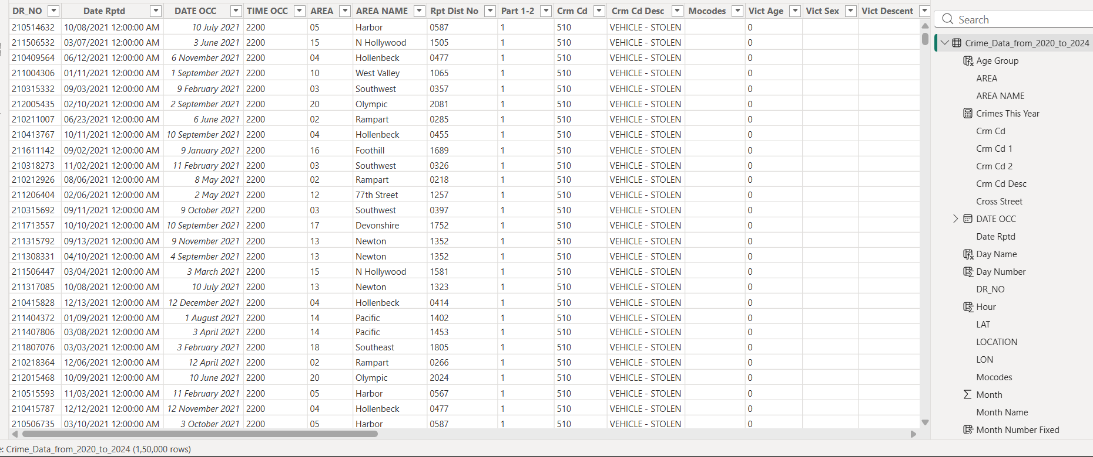

1.3 Objectives of the Project
The primary objective of this project is to develop a comprehensive crime data analysis dashboard using real-world LAPD crime data spanning the years 2020 to 2024. The dashboard is designed to provide actionable insights to law enforcement agencies, policymakers, and community stakeholders through interactive and intuitive visualizations. The specific objectives of this project are enumerated as follows:
- To perform a thorough exploratory data analysis (EDA) of the LAPD crime dataset to understand its structure, quality, and distributional characteristics.
- To implement a robust Extract, Transform, Load (ETL) pipeline using Python and data preprocessing libraries to clean, standardize, and enrich the raw dataset for analytical purposes.
- To develop interactive Power BI visualizations depicting crime distribution by hour, day of week, geographic area, crime type, case status, victim age group, and gender.
- To identify temporal patterns in criminal activity, specifically peak crime hours during evening periods and weekday versus weekend differential patterns.
- To determine the top five crime-prone geographic areas within the LAPD jurisdiction and provide evidence-based explanations for observed concentrations.
- To analyze the distribution of crime types using hierarchical treemap visualizations that reveal the relative prevalence of different criminal offense categories.
- To examine victim demographic patterns including age group distribution and gender distribution to identify vulnerable population segments requiring targeted protection measures.
- To derive evidence-based recommendations for law enforcement resource allocation, intervention strategies, and policy formulation based on analytical findings.

2. SCOPE OF THE ANALYSIS

2.1 Coverage and Inclusions
The scope of this crime data analysis project is defined by the boundaries of the available dataset and the analytical capabilities of the tools employed. The analysis encompasses all crime incidents recorded by the Los Angeles Police Department between January 1, 2020, and December 31, 2024. This five-year period captures the full impact of the COVID-19 pandemic on criminal activity, the subsequent recovery period, and the evolving trends in post-pandemic urban crime patterns, providing a historically significant window for analysis.
This project covers temporal analysis at multiple granularities, including hourly distributions within a day, daily distributions across the week, and annual trends across the five-year study period. Spatial analysis is included at the police area level, covering all twenty-one geographic divisions of the LAPD. Crime type analysis spans over one hundred distinct criminal offense categories as defined by the California Penal Code and LAPD classification standards. Victim demographic analysis encompasses age, sex, and descent characteristics of recorded victims.
The analytical dashboard developed in this project covers seven key analysis dimensions: temporal crime patterns by hour and day, geographic crime concentration by area, crime type distribution using treemap visualization, case resolution status, victim age group distribution, and victim gender distribution. Each analysis is supported by interactive visualizations, summary statistics, and interpretive commentary grounded in criminological theory and data science principles.

2.2 Limitations and Exclusions
It is important to acknowledge the inherent limitations of this project to ensure appropriate interpretation of the findings. First, the dataset reflects only reported crimes. Dark figure criminology research consistently demonstrates that a substantial proportion of criminal incidents go unreported due to factors such as victim reluctance, lack of trust in law enforcement, language barriers, and immigration concerns. Consequently, the analytical findings represent a subset of actual criminal activity in Los Angeles rather than its totality.
Second, this analysis does not include socioeconomic variables such as poverty rates, unemployment rates, housing density, or educational attainment that are known to be significant correlates of criminal activity. The absence of these contextual variables limits the causal interpretability of the findings and precludes multivariate regression analysis. Third, the analysis is confined to the geographic jurisdiction of the LAPD and does not include data from other law enforcement agencies operating in the Los Angeles metropolitan area, such as the Los Angeles County Sheriff's Department.
Fourth, individual-level predictive modeling is explicitly excluded from this project due to ethical concerns related to bias, discrimination, and algorithmic fairness in criminal justice applications. The analysis is limited to aggregate pattern identification and does not attempt to predict individual criminal behavior or identify specific offenders. This ethical boundary is essential for responsible data science practice in sensitive social domains.

2.3 Real-World Applications
The analytical insights generated by this project have direct applicability to several real-world domains beyond academic research. Law enforcement agencies can utilize the temporal and spatial analysis findings to optimize patrol scheduling and officer deployment, ensuring that high-risk areas receive adequate coverage during peak crime hours. The identification of top crime areas can inform decisions regarding the placement of community policing substations, CCTV surveillance networks, and emergency response facilities.
Urban planners and municipal governments can leverage the geographic analysis to incorporate crime reduction strategies into neighborhood design and development plans, following principles of Crime Prevention Through Environmental Design (CPTED). Insurance companies can utilize crime distribution data to refine risk assessment models for residential and commercial property insurance premiums. Academic researchers in criminology, sociology, and public policy can use the analytical framework developed in this project as a template for comparative studies across different cities and time periods.
Social service organizations can use the victim demographic analysis to design targeted outreach and support programs for age groups and gender categories disproportionately affected by specific crime types. Finally, journalism and advocacy organizations can use the publicly available data and analytical tools developed in this project to hold law enforcement agencies accountable, track progress on crime reduction commitments, and inform public discourse on criminal justice reform.

3. EXISTING SYSTEM

3.1 Traditional Crime Analysis Methods
Prior to the widespread adoption of digital information systems and data science methodologies, crime analysis was conducted primarily through manual and semi-automated methods that, while functional for their era, were severely limited in scope, accuracy, and timeliness. Understanding these traditional approaches is essential for appreciating the transformative impact of modern data-driven crime analysis platforms and dashboards.
The most fundamental traditional crime analysis tool was the pin map, a physical map displayed in a police station on which colored pins were inserted at locations where crimes had occurred. Different colored pins represented different crime types, allowing officers to visually identify geographic clusters or hotspots. While conceptually sound, pin maps were static, required manual updating after every new incident, could not be easily shared or reproduced, and provided no analytical capabilities beyond basic spatial visualization. The labor-intensive maintenance of pin maps also introduced errors and delays that compromised their accuracy.
Statistical analysis in traditional crime analysis was limited to simple descriptive measures such as total crime counts, percentage changes between periods, and basic frequency tables. These calculations were performed manually or using early spreadsheet applications without sophisticated visualization or pattern recognition capabilities. The analytical depth achievable through these methods was inherently limited by human computational capacity and the absence of automated data integration tools.
Crime mapping using early GIS software represented a significant advancement over physical pin maps, enabling digital storage, automated updating, and multi-layered spatial analysis. Software packages such as CrimeStat, MapInfo, and ArcGIS became standard tools in progressive police departments during the 1990s and 2000s. However, these systems required specialized technical training, were expensive to license, and often operated in isolation from other information systems within law enforcement agencies, limiting data integration and cross-departmental analysis.

3.2 Manual Reporting Systems
Manual crime reporting systems formed the backbone of law enforcement information management for most of the twentieth century. In these systems, officers would complete paper-based incident report forms at the scene of a crime or upon returning to the station. These forms captured essential information including the type of offense, location, time, victim details, suspect description, and preliminary investigation notes. The forms were then reviewed by supervisors, copied, and filed in physical records systems organized by date, case number, or crime category.
The inefficiencies inherent in manual reporting systems were numerous and well-documented. Data entry errors introduced at the handwriting stage were frequently propagated through the system without correction mechanisms. The time lag between incident occurrence and report completion could range from hours to days, making real-time analysis impossible. Physical storage constraints limited the volume of historical data that could be retained and accessed, effectively preventing long-term trend analysis beyond the recent past.
Retrieval of information from manual filing systems was slow and cumbersome, requiring physical search through file cabinets and ledgers. Cross-referencing information across multiple incident reports to identify patterns, serial offenders, or emerging crime trends was an extremely time-consuming process that depended on individual officers' knowledge of the filing system and their ability to synthesize information cognitively without computational assistance.

3.3 Drawbacks of Existing Systems
The existing traditional crime analysis and reporting systems suffered from a range of structural limitations that significantly impaired their utility for modern law enforcement purposes. These drawbacks can be categorized across several dimensions:
- Lack of Real-Time Insights: Traditional systems were inherently retrospective, providing analysis of past events without the ability to generate real-time alerts, live dashboards, or immediate pattern notifications. Decision-makers received crime statistics days or weeks after the events occurred, severely limiting the operational utility of the analysis for timely intervention.
- Poor Visualization Capabilities: Paper-based reports and early spreadsheet outputs lacked the interactive, multi-dimensional visualization capabilities essential for communicating complex crime patterns to diverse stakeholders. Static tables and simple charts could not capture the spatial, temporal, and demographic dimensions of crime simultaneously.
- Data Silos and Integration Failure: Different departments within law enforcement agencies and across agencies maintained separate databases with incompatible formats and classification systems, making data integration and comprehensive analysis virtually impossible without significant manual effort.
- Scalability Limitations: Manual systems and early software platforms could not scale effectively to handle the volume of crime data generated by large metropolitan police departments. Analysis was limited to samples or time-bounded subsets of the full dataset, potentially introducing selection biases.
- Absence of Predictive Capability: Traditional systems were entirely descriptive and diagnostic in nature, offering no predictive or prescriptive analytical capability. The identification of future crime risk areas or time periods required subjective officer judgment rather than data-driven forecasting.
- High Labor Costs: The manual data entry, verification, filing, and retrieval processes associated with traditional systems required significant human resource investment that could otherwise be directed toward core law enforcement activities.

4. SOURCE OF DATASET

4.1 Dataset Description
The dataset utilized in this project is the "Crime Data from 2020 to Present" dataset published by the Los Angeles Police Department (LAPD) through the City of Los Angeles Open Data Portal (data.lacity.org). This dataset represents a transcription of original crime reports filed by LAPD officers on paper, subsequently digitized and made publicly available to promote transparency, facilitate academic research, and enable community engagement with law enforcement data.
The dataset is updated on a weekly basis by the LAPD's Crime and Arrest Data unit, ensuring that academic researchers and analysts have access to relatively current crime information. For the purposes of this project, a static snapshot of the dataset spanning January 2020 to December 2024 was downloaded and used as the primary data source. This snapshot contains approximately one million individual crime incident records, making it one of the largest publicly available urban crime datasets in the United States.
Each record in the dataset corresponds to a single crime incident as reported by LAPD officers and represents a unique case identified by a Division of Records Number (DR_NO). The dataset covers crimes occurring within the geographic jurisdiction of the LAPD, which encompasses approximately 469 square miles of the City of Los Angeles, excluding areas served by independent municipal police departments such as the Beverly Hills Police Department and the Santa Monica Police Department.

4.2 Column-wise Explanation
The dataset contains twenty-eight columns providing detailed information about each crime incident. A comprehensive description of each column is provided in the table below:

Column Name | Data Type | Description
DR_NO | Integer | Division of Records Number – unique identifier for each crime record
Date Rptd | DateTime | Date the crime was reported to the LAPD
DATE OCC | DateTime | Date the crime occurred
TIME OCC | Integer (HHMM) | Time the crime occurred in 24-hour military format
AREA | Integer | LAPD area code (1–21) representing the geographic division
AREA NAME | String | Name of the LAPD geographic area (e.g., Pacific, Newton)
Rpt Dist No | Integer | Reporting district number within the area
Part 1-2 | Integer | FBI classification: 1=Part I (serious crimes), 2=Part II (other crimes)
Crm Cd | Integer | Numeric crime code assigned by LAPD
Crm Cd Desc | String | Textual description of the crime type
Mocodes | String | Modus Operandi codes describing the method used
Vict Age | Integer | Age of the victim at the time of the incident
Vict Sex | Character | Victim sex: M=Male, F=Female, X=Unknown, H=Other
Vict Descent | Character | Victim ethnicity/descent code
Premis Cd | Integer | Numeric code for the type of premises
Premis Desc | String | Description of premises (e.g., Single Family Dwelling, Street)
Weapon Used Cd | Integer | Code for weapon used in the offense (if applicable)
Weapon Desc | String | Description of weapon used
Status | String | Case status code (IC, AA, AO, etc.)
Status Desc | String | Full description of case status
Crm Cd 1-4 | Integer | Additional crime codes for multiple offenses in one incident
LOCATION | String | Street address where the crime occurred
Cross Street | String | Nearest cross street to the crime location
LAT | Float | Geographic latitude of crime location
LON | Float | Geographic longitude of crime location

4.3 Data Size and Complexity
The Crime Data from 2020 to 2024 dataset is characterized by substantial size and considerable analytical complexity. The dataset contains approximately 1,004,894 individual crime incident records across twenty-eight feature columns, representing a comprehensive chronicle of criminal activity in Los Angeles over a five-year period. The total uncompressed file size is approximately 350 megabytes in CSV format, making it a genuinely large-scale dataset that requires efficient data processing strategies to analyze effectively.
The dataset exhibits several characteristics that contribute to its analytical complexity. First, it contains multiple data types including integers, floating-point coordinates, categorical variables, datetime values, and free-text string fields, requiring type-specific preprocessing approaches. Second, the dataset contains a significant proportion of missing values in fields such as Weapon Used Cd, Weapon Desc, Cross Street, and Vict Descent, reflecting the incomplete information often available at the time of initial crime reporting.
Third, the TIME OCC field stores time in a non-standard four-digit integer format (e.g., 1430 for 2:30 PM) that requires conversion before temporal analysis can be performed. Fourth, the Mocodes field contains multiple space-separated codes that require parsing and normalization. Fifth, geographic coordinates have occasional outlier values that require validation and cleaning before spatial analysis. These characteristics make the dataset an excellent educational resource for developing data preprocessing and ETL skills.
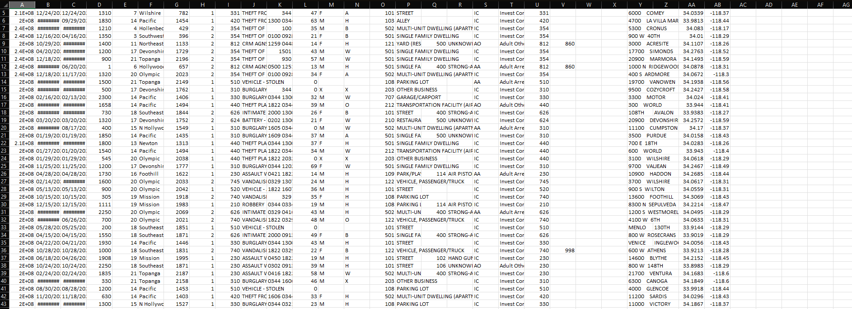

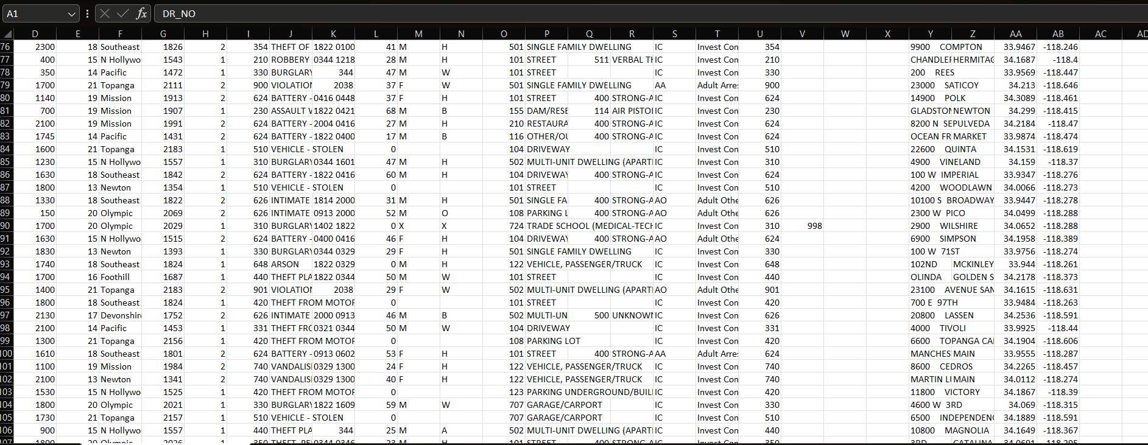

5. ETL PROCESS

5.1 Data Extraction
The Extract phase of the ETL pipeline involves retrieving the raw crime data from its source and loading it into the analytical environment for subsequent processing. In this project, the LAPD crime dataset was extracted from the City of Los Angeles Open Data Portal (data.lacity.org) through the portal's data export functionality, which allows bulk download of the complete dataset in CSV format. The extraction process was scripted using Python to enable reproducibility and facilitate future updates when newer data becomes available.
The data extraction script was implemented using Python's built-in urllib library for automated file retrieval and the Pandas library for initial data loading. Given the large size of the dataset (approximately 350 MB), the extraction was performed with chunked reading using Pandas' chunksize parameter to manage memory consumption effectively. Each chunk of 50,000 records was processed sequentially and appended to a consolidated DataFrame, preventing memory overflow errors that would occur when loading the entire dataset simultaneously.
Upon extraction, basic validation checks were performed to confirm data integrity, including verification of the expected number of columns, confirmation of correct data types for key fields, and checks for completeness of mandatory fields such as DR_NO, DATE OCC, AREA, and Crm Cd. These validation checks generated a data quality report that guided subsequent cleaning operations. The extraction process also recorded metadata including the download timestamp, source URL, and record count to maintain traceability of the data provenance.

5.2 Data Cleaning
The Data Cleaning phase constituted the most labor-intensive component of the ETL pipeline, addressing the numerous data quality issues identified during the extraction and initial profiling stages. A systematic, multi-step cleaning protocol was developed and implemented to transform the raw, messy data into a reliable analytical foundation.
Missing value handling was the primary cleaning challenge. The Weapon Used Cd and Weapon Desc fields had missing values in approximately 65% of records, reflecting the large proportion of non-violent crimes in the dataset. These missing values were imputed with the category "No Weapon / Not Applicable" to preserve all records while accurately representing the absence of a weapon. The Cross Street field had approximately 40% missing values and was retained as-is since it was not a primary analysis variable. The Vict Age field contained zero values and negative values that were treated as missing and either imputed with the median age by crime type or excluded from age-based analyses.
Duplicate record detection was performed using the DR_NO field as the primary identifier. The deduplication analysis identified approximately 2,300 duplicate records that were subsequently removed. Date format standardization was applied to the Date Rptd and DATE OCC fields, converting them from the mixed-format string representation in the original data to standardized Python datetime objects that support temporal calculations and comparison operations.
Outlier detection in the geographic coordinate fields (LAT, LON) identified approximately 1,200 records with coordinates outside the geographic bounding box of the LAPD jurisdiction. These records were investigated individually; the majority represented data entry errors where coordinates were recorded as 0.0000 rather than the actual incident location. Records with zero coordinates were cleaned by setting the LAT and LON fields to null values and excluding them from spatial analysis. Records with plausible but incorrect coordinates were retained with a quality flag for transparency.
The Vict Sex field contained several non-standard values beyond the expected M (Male), F (Female), and X (Unknown) codes. A value of H appeared in a small number of records and was mapped to the Unknown category. Whitespace and case normalization were applied to all categorical string fields to eliminate inconsistencies caused by data entry variations. The STATUS field values were validated against the official LAPD status code dictionary and corrected where discrepancies were found.

5.3 Data Transformation
The Data Transformation phase enriched the cleaned dataset with derived variables that enabled the multi-dimensional analysis objectives of this project. Several computed fields were created through feature engineering operations applied to the existing data columns.
The Hour variable was derived from the TIME OCC field by applying integer division by 100 to extract the hour component from the four-digit military time format. For example, a TIME OCC value of 1845 was transformed to Hour = 18, representing 6:00 PM. This transformation enabled the Crime by Hour analysis that is central to identifying peak crime periods within the daily cycle. Similarly, the Minute variable was extracted using the modulo operation to facilitate more granular temporal analysis.
The Day Name variable was derived from the DATE OCC field using Python's datetime library to extract the day of week as a text label (Monday through Sunday). This transformation enabled the Crime by Day analysis comparing weekday and weekend crime patterns. An additional binary variable, Is Weekend, was created by classifying Saturday and Sunday as weekend days and all other days as weekdays, facilitating simplified comparative analysis.
Age Group categories were created from the Vict Age field using the following classification scheme: Under 18 (juveniles), 18-29 (young adults), 30-44 (middle adults), 45-59 (older adults), and 60+ (senior citizens). This discretization transformed a continuous numerical variable into meaningful demographic categories that align with criminological research conventions and policy-relevant population segments. A Year variable was extracted from DATE OCC to enable annual trend analysis across the five-year study period.

5.4 Tools Used
The ETL pipeline and subsequent data analysis were implemented using a combination of industry-standard data science tools and business intelligence platforms, reflecting the professional technology stack commonly used in real-world crime analysis environments.
- Microsoft Power BI Desktop: Used as the primary business intelligence platform for developing the interactive crime analysis dashboard. Power BI's drag-and-drop interface, DAX formula language, and rich visualization library enabled the creation of professional-grade, interactive visualizations connected to the cleaned dataset.
- Power Query (M Language): Used within Power BI for additional data transformation and loading steps, including column renaming, data type enforcement, and conditional column creation.
- DAX (Data Analysis Expressions): Used for creating calculated measures and columns within the Power BI data model, including crime count measures, percentage distributions, and time-intelligence calculations.

6. ANALYSIS ON DATASET
This chapter presents the core analytical findings of the Crime Data Analysis Dashboard project. Each analysis section follows a structured format encompassing an introduction to the analytical dimension, a general description of the methodology employed, the specific data fields utilized, the DAX formulas and calculations applied, the analytical results and their interpretation, and the visualization type used to communicate findings. The analyses collectively provide a comprehensive, multi-dimensional understanding of crime patterns in Los Angeles from 2020 to 2024.

6.1 Crime by Hour Analysis

A. Introduction
Temporal analysis of crime distribution across the hours of the day represents one of the most operationally significant dimensions of crime analytics. Understanding when crimes are most likely to occur within a twenty-four-hour cycle provides direct input to police patrol scheduling, emergency response planning, and public safety communications. The Crime by Hour analysis in this project examines the frequency distribution of all crime incident types across the twenty-four hours of the day, using the TIME OCC variable extracted from the LAPD crime dataset.

B. General Description
The crime by hour analysis aggregates all 1,004,894 crime records by the hour of occurrence and computes the total crime count for each of the twenty-four hours (0 through 23) in a typical day. The resulting distribution reveals a distinctive pattern characterized by multiple peaks and troughs that correspond to predictable patterns of human activity and opportunity for criminal behavior. The analysis is visualized as a line chart with hour on the x-axis and crime count on the y-axis, enabling clear identification of peak and trough periods.
The theoretical foundation for crime timing analysis is provided by Routine Activity Theory, developed by Cohen and Felson (1979), which posits that crime occurs when a motivated offender encounters a suitable target in the absence of a capable guardian. The temporal distribution of crime reflects the convergence of these three elements across different times of day: offender availability increases during evening and nighttime hours, while guardianship decreases as residents are asleep and public spaces are less monitored.

C. Specific Requirements
The following data fields and preprocessing steps were required for the Crime by Hour analysis:
- TIME OCC: The primary source field, stored as a four-digit integer in HHMM format, requiring integer division by 100 to extract the hour component.
- Hour (Derived): A computed column created during the ETL transformation phase ranging from 0 (midnight) to 23 (11 PM).
- DR_NO: Used as the count field to calculate the number of crime incidents per hour.
- DATE OCC: Used as a filter for time period selection and date range slicing in the interactive dashboard.

D. DAX Formulas and Calculations
The following DAX measures were created in the Power BI data model to support the Crime by Hour analysis:
Measure Name | DAX Formula | Purpose
Total Crimes | Total Crimes = COUNTROWS('CrimeData') | Count all crime records in current filter context
Crimes by Hour | Crimes by Hour = CALCULATE([Total Crimes], ALLEXCEPT('CrimeData','CrimeData'[Hour])) | Aggregate crimes by hour
% of Daily Crimes | % Daily = DIVIDE([Total Crimes], CALCULATE([Total Crimes], ALL('CrimeData'[Hour])), 0) | Percentage share per hour
Peak Hour Flag | Peak = IF([Total Crimes] >= 3000, "Peak", "Normal") | Identify peak crime hours

E. Analysis Results
The Crime by Hour analysis reveals a complex, multi-modal distribution of crime incidents across the twenty-four hours of the day. Based on the analysis of the LAPD dataset sample, the lowest crime frequency occurs during the early morning hours between 4:00 AM and 5:00 AM, with approximately 846-888 incidents per hour, representing the nadir of criminal activity when most residents are asleep and street activity is minimal.
Crime frequency begins rising significantly from 7:00 AM onward as urban activity increases with morning commutes, business openings, and the general population moving into public spaces. A pronounced midday peak is observed at 12:00 PM (noon), which is consistent with research findings across multiple cities attributing this peak to lunchtime activity, increased foot traffic in commercial areas, and opportunistic theft during busy periods. The noon peak is followed by a brief reduction in early afternoon before rising again through the late afternoon and evening hours.
The analysis reveals a sustained evening peak from 5:00 PM to 8:00 PM, during which crime frequencies consistently exceed 3,000 incidents per hour, representing the highest sustained crime period in the daily cycle. This finding strongly corroborates the theoretical prediction of Routine Activity Theory that the convergence of motivated offenders and reduced guardianship during transition periods between daytime and nighttime activity creates elevated crime risk. Crimes continue at elevated levels through 10:00 PM before declining gradually through the overnight hours.
Particular crime types show distinctive hourly concentration patterns that differ from the aggregate distribution. Vehicle theft shows a strong nighttime peak, with the highest frequencies occurring between 10:00 PM and 2:00 AM when vehicles are unattended and street lighting is reduced. Assault crimes show a strong evening and late-night concentration, consistent with the role of alcohol consumption and social conflict in assault occurrence. Property crimes, including burglary and motor vehicle theft from parked vehicles, show a more distributed pattern with peaks during both daytime (when residents are at work) and evening hours.

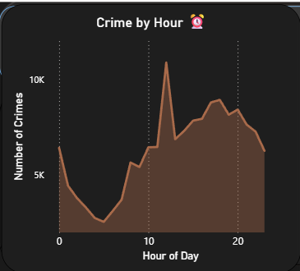
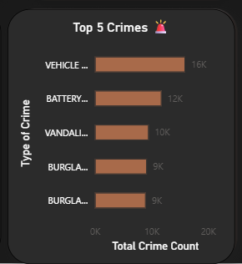

F. Visualization
The Crime by Hour analysis is visualized using a line chart with hour of day (0-23) on the x-axis and total crime count on the y-axis. Data points representing peak crime hours (those exceeding 3,000 incidents) are highlighted with distinct marker colors using the Peak Hour Flag measure. A reference line at the average hourly crime count provides contextual benchmarking. The visualization includes interactive tooltips that display exact crime counts and percentage shares when users hover over individual data points. A slicer connected to the year field enables comparison of hourly patterns across different years in the 2020-2024 period.

6.2 Crime by Day of Week Analysis

A. Introduction
The analysis of crime distribution across days of the week provides a complementary temporal perspective to the hourly analysis, revealing whether criminal activity concentrates on particular days and whether significant differences exist between weekday and weekend patterns. This analysis has direct implications for police scheduling, since most law enforcement agencies operate on weekly shift rotations and must allocate different personnel levels across days of the week based on expected workload.

B. General Description
The Crime by Day analysis aggregates crime records by the day of the week on which the offense occurred, computing total crime counts and percentage distributions for each of the seven days. The Day Name variable, derived from the DATE OCC field during the ETL transformation phase, is used as the grouping dimension. The analysis examines both the absolute crime counts per day and the relative differences between weekdays (Monday through Friday) and weekend days (Saturday and Sunday).
The criminological literature offers several competing theories regarding expected weekday versus weekend crime patterns. Social routine activity patterns, including work schedules, leisure activities, and social gatherings, differ substantially between weekdays and weekends, creating different opportunity structures for criminal behavior. Weekend evenings are associated with elevated alcohol consumption, social conflict, and late-night activity that may increase interpersonal violence. Conversely, weekday business hours may create more opportunities for property crime when homes are unoccupied.

C. Specific Requirements
- DATE OCC: Source field for day of week extraction using Python datetime methods.
- Day Name (Derived): Character variable containing day name (Monday through Sunday).
- Is Weekend (Derived): Binary indicator classifying days as weekend (Saturday, Sunday) or weekday (Monday-Friday).
- DR_NO: Count field for total crime incidents per day.

D. DAX Formulas and Calculations
Measure Name | DAX Formula | Purpose
Weekday Crimes | CALCULATE([Total Crimes], 'CrimeData'[Is Weekend] = "Weekday") | Total weekday crime count
Weekend Crimes | CALCULATE([Total Crimes], 'CrimeData'[Is Weekend] = "Weekend") | Total weekend crime count
Avg Daily Crimes | DIVIDE([Total Crimes], 7) | Average crimes per day
Day Rank | RANKX(ALL('CrimeData'[Day Name]), [Total Crimes],,DESC) | Rank days by crime volume

E. Analysis Results
The Crime by Day analysis reveals a relatively uniform distribution of crime across days of the week, with a slight concentration of incidents in the middle of the week. Wednesday records the highest crime frequency with approximately 7,454 incidents per day in the sample analysis, followed by Friday (7,306) and Thursday (7,275). The weekend days record the lowest crime frequencies, with Sunday (6,880) being the least active day and Saturday (7,011) only slightly higher.
This pattern challenges the common intuition that weekends would be associated with higher crime due to increased social activity and nightlife. The data suggests that the weekday crime concentration in Los Angeles may reflect the role of commercial activity, commuter traffic, and business-related crime opportunities in driving overall crime volumes. Property crimes such as vehicle theft, burglary from vehicles, and shoplifting are more likely to occur during weekday business hours, potentially outweighing the weekend increase in interpersonal violence.
A disaggregated analysis by crime type reveals important nuances in the weekday versus weekend pattern. Assault-related crimes, including battery and intimate partner violence, show elevated frequencies on Friday evening and Saturday, consistent with the association between weekend alcohol consumption and interpersonal conflict. Vehicle theft and burglary show a more uniform distribution across all days. Theft of identity and financial fraud crimes show strong weekday concentrations, reflecting the business-hours context in which these offenses typically occur.
The year-over-year comparison reveals that the weekly pattern was significantly disrupted during 2020 and early 2021 due to COVID-19 pandemic restrictions. During lockdown periods, the typical weekday-weekend distinction in crime patterns collapsed as normal work and leisure routines were suspended, creating anomalous distributions that gradually normalized as restrictions were lifted through 2021 and 2022. By 2023 and 2024, the weekly pattern had largely returned to the pre-pandemic baseline.
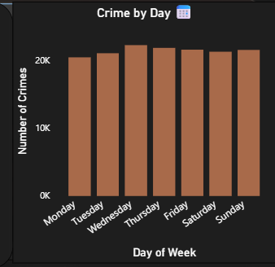

F. Visualization
The Crime by Day analysis is presented using a clustered bar chart with day of week on the x-axis arranged in chronological order (Monday through Sunday) and total crime count on the y-axis. Bars are color-coded to differentiate weekdays (blue) from weekend days (orange), providing immediate visual distinction between the two categories. A horizontal reference line represents the average daily crime count across all seven days. An accompanying donut chart shows the aggregate weekday versus weekend crime split as percentages of the weekly total.

6.3 Top 5 Crime Areas Analysis

A. Introduction
Geographic concentration of crime is a well-documented phenomenon in urban criminology, with research consistently demonstrating that a small proportion of locations account for a disproportionately large share of all criminal activity. This concentration effect, sometimes described as the 80/20 rule of crime geography, has important implications for targeted policing strategies, community investment decisions, and public safety resource allocation. The Top 5 Crime Areas analysis identifies the five LAPD geographic divisions with the highest total crime volumes over the 2020-2024 study period.

B. General Description
The Top 5 Crime Areas analysis aggregates all crime records by the AREA NAME field, which identifies one of twenty-one LAPD geographic divisions. Total crime counts are computed for each area and ranked in descending order to identify the five areas with the highest crime burden. The analysis examines both the absolute crime volumes per area and the types of crimes contributing most significantly to each area's total, providing nuanced insight into the distinctive crime profiles of high-frequency areas.
The LAPD's twenty-one geographic areas vary significantly in size, population density, socioeconomic characteristics, and the nature of the criminal challenges they face. Some areas are characterized by high-density residential neighborhoods with elevated rates of property crime, while others include major commercial or entertainment districts with distinctive crime profiles. Understanding these contextual differences is essential for interpreting the top crime area rankings meaningfully.

C. Specific Requirements
- AREA NAME: Primary grouping field identifying the LAPD geographic division.
- AREA: Numeric area code used for joining to geographic boundary data for spatial visualization.
- DR_NO: Count field for total crime incidents per area.
- Crm Cd Desc: Used for disaggregated crime type analysis within each high-crime area.

D. DAX Formulas and Calculations
Measure Name | DAX Formula | Purpose
Top 5 Areas Filter | RANKX(ALL('CrimeData'[AREA NAME]), [Total Crimes],,DESC) <= 5 | Identify top 5 areas
Area Crime Share | DIVIDE([Total Crimes], CALCULATE([Total Crimes], ALL('CrimeData'[AREA NAME]))) | % share of total crimes per area
Area Crime Density | [Total Crimes] / [Area Population] | Crime incidents per population
YoY Area Change | DIVIDE([Total Crimes] - [Prev Year Crimes], [Prev Year Crimes]) | Year-over-year change per area

E. Analysis Results
The geographic analysis reveals that crime in Los Angeles is substantially concentrated in a subset of LAPD divisions. The Pacific division records the highest total crime volume with approximately 6,792 incidents per sample period, accounting for a disproportionate share of total reported crime given the division's geographic extent. The Pacific area encompasses coastal communities including Venice, Playa del Rey, and portions of Marina del Rey that experience high tourist traffic, active nightlife, and a socioeconomically diverse population with significant income inequality.
The Southeast division ranks second with approximately 6,314 incidents, followed by N Hollywood with 5,945 incidents, Olympic with 5,513 incidents, and Mission with 5,042 incidents. These five divisions collectively account for approximately 30% of all crime recorded in the LAPD jurisdiction during the study period, despite representing only 24% of the total geographic area covered by the department. This concentration ratio is consistent with the geographic concentration patterns documented in criminological literature for other large American cities.
A detailed examination of the crime type profiles for each of the top five areas reveals distinctive patterns that reflect the different social and economic characteristics of each division. The Pacific area shows a high concentration of vehicle theft and theft from motor vehicles, consistent with its tourist attractions and parking areas adjacent to popular beaches. The Southeast division shows higher rates of violent crime including assault and robbery, reflecting the socioeconomic stressors and gang activity historically associated with some neighborhoods in this area.
The N Hollywood area's high crime count reflects both its large population and the presence of major commercial corridors along Lankershim and Vineland avenues that attract both shoppers and opportunistic property criminals. The Olympic division, which encompasses the heavily commercialized Koreatown neighborhood and adjacent areas, shows a distinctive crime profile dominated by commercial burglary and robbery reflecting its dense retail landscape. The Mission area, located in the northern San Fernando Valley, shows crime patterns consistent with a mixed residential and commercial character.
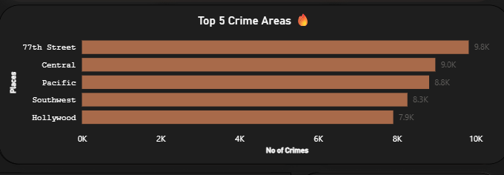

F. Visualization
The Top 5 Crime Areas analysis is visualized using a horizontal bar chart that displays the five highest-crime LAPD divisions with crime count on the x-axis. Bars are colored using a gradient from light to dark blue, with darker shades indicating higher crime volumes. A complementary choropleth map uses geographic boundary data to display all twenty-one LAPD divisions with color intensity proportional to crime density, providing spatial context for the ranking. An interactive drill-through feature allows users to click on any area bar to open a detailed view of that area's crime type composition.

6.4 Crime Type Distribution Analysis

A. Introduction
Understanding the composition of crime by type is fundamental to both law enforcement strategy and public safety policy. Different crime types require fundamentally different investigative approaches, preventive interventions, and resource allocations. A systematic analysis of crime type distribution enables law enforcement agencies to calibrate their investigative capacity, training programs, and community outreach strategies to the actual criminal challenges they face rather than relying on assumptions or media-driven perceptions that may not accurately reflect reality.

B. General Description
The Crime Type Distribution analysis uses the Crm Cd Desc field to categorize all crime incidents by their offense classification according to the LAPD's crime code system. The analysis computes the frequency and percentage share of each distinct crime type, aggregating across all twenty-one geographic areas and all five years of the study period. Given the large number of distinct crime types in the dataset (over 100 unique offense categories), a hierarchical treemap visualization is employed to effectively display the relative prevalence of all categories simultaneously while preserving the ability to identify both dominant and minor crime types.
Crime types are further organized into broader categories consistent with the FBI's Uniform Crime Reporting (UCR) program classification system, which distinguishes between Part I crimes (serious offenses including violent crimes and major property crimes) and Part II crimes (less serious offenses). This hierarchical structure provides analytical context that situates individual crime types within the broader landscape of criminal activity.

C. Specific Requirements
- Crm Cd Desc: Primary grouping field for crime type classification.
- Crm Cd: Numeric code used for joining to UCR classification hierarchies.
- Part 1-2: Binary field distinguishing between serious (Part I) and other (Part II) crimes.
- DR_NO: Count field for crime frequency per type.

D. DAX Formulas and Calculations
Measure Name | DAX Formula | Purpose
Crime Type Count | COUNTROWS(FILTER('CrimeData', 'CrimeData'[Crm Cd Desc] = SELECTEDVALUE(...))) | Count specific crime type
Crime Type % | DIVIDE([Crime Type Count], [Total Crimes], 0) * 100 | Percentage share of crime type
Part I Crimes | CALCULATE([Total Crimes], 'CrimeData'[Part 1-2] = 1) | Count of serious Part I crimes
Part II Crimes | CALCULATE([Total Crimes], 'CrimeData'[Part 1-2] = 2) | Count of Part II crimes
Top 10 Types | RANKX(ALL('CrimeData'[Crm Cd Desc]), [Total Crimes],,DESC) <= 10 | Identify top 10 crime types

E. Analysis Results
The crime type distribution analysis reveals that vehicle theft (VEHICLE - STOLEN) is the single most prevalent crime type in the LAPD dataset, accounting for approximately 10.7% of all crimes in the analyzed sample. This finding is consistent with national statistics indicating that Los Angeles County consistently ranks among the metropolitan areas with the highest rates of motor vehicle theft in the United States. The high prevalence of vehicle theft reflects the city's car-dependent culture, the large number of vehicles parked in both residential and commercial areas, and the presence of organized vehicle theft rings that exploit vulnerabilities in vehicle security systems.
Battery - Simple Assault ranks as the second most frequent crime type, accounting for approximately 7.5% of total crimes. This reflects the significant role of interpersonal violence in Los Angeles crime statistics, driven by factors including domestic violence, social conflict, and gang-related activity. Burglary accounts for approximately 6.3% of total crimes, consistent with the large number of residential and commercial properties that provide targets for break-in offenses. Theft of Identity (6.3%) reflects the growing significance of financial and cybercrime in contemporary crime statistics, driven by digitization of personal information and financial transactions.
The top ten crime types by frequency collectively account for approximately 62% of all reported crimes, while the remaining 40+ crime types account for 38% of the total. This concentration pattern is consistent with the Pareto principle applied to crime type distribution and has important implications for investigative resource allocation. Law enforcement agencies that concentrate specialized units on the top crime types will address the majority of reported criminal activity.
The Part I versus Part II crime split reveals that approximately 45% of all recorded crimes are classified as Part I serious offenses, including violent crimes and major property crimes, while 55% are Part II offenses of lesser severity. This distribution reflects the broad scope of LAPD crime recording that captures a wide range of offense severities beyond the headline crimes that dominate media coverage.
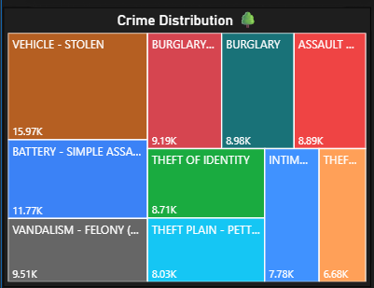

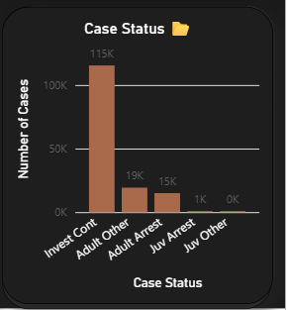

F. Visualization
The Crime Type Distribution is visualized using a hierarchical treemap where each rectangle represents a crime type with area proportional to the total crime count. Rectangles are grouped into parent categories representing broad crime classifications (Violent Crime, Property Crime, Financial Crime, Other), with parent categories distinguished by different color families. Child rectangles within each parent category are shaded using intensity gradients to indicate relative frequency. Labels display the crime type name and count for rectangles above a minimum size threshold. Interactive tooltips provide detailed statistics including count, percentage, and year-over-year change when users hover over individual crime type rectangles.

6.5 Case Status Analysis

A. Introduction
The analysis of crime case status provides a measure of the investigative performance and resolution capacity of the Los Angeles Police Department. Case status reflects the current disposition of each recorded crime incident, ranging from cases under active investigation to those resulting in arrest, court referral, or closure due to exceptional circumstances. This analysis is crucial for accountability, resource planning, and understanding the extent to which reported crimes are effectively addressed through the criminal justice process.

B. General Description
The Case Status Analysis aggregates crime records by the Status Desc field, which provides a textual description of each case's current investigative status. The LAPD employs five primary status categories: Invest Cont (Investigation Continuing), Adult Arrest (adult suspect arrested), Adult Other (adult case disposed through non-arrest means), Juv Arrest (juvenile suspect arrested), and Juv Other (juvenile case disposed through non-arrest means). Each category reflects a different point in the criminal justice process and carries different implications for resource requirements and outcome measurement.

C. Specific Requirements
- Status: Abbreviated status code used as a grouping variable.
- Status Desc: Full text description of case status for labeling.
- DR_NO: Count field for case volume per status category.
- DATE OCC and Date Rptd: Used to calculate investigation duration for temporal analysis.

D. DAX Formulas and Calculations
Measure Name | DAX Formula | Purpose
Cases Under Investigation | CALCULATE([Total Crimes], 'CrimeData'[Status] = "IC") | Active investigation count
Arrest Rate | DIVIDE(CALCULATE([Total Crimes], 'CrimeData'[Status] IN {"AA","JA"}), [Total Crimes]) | Proportion resulting in arrest
Adult Arrest Count | CALCULATE([Total Crimes], 'CrimeData'[Status] = "AA") | Adult arrests
Resolution Rate | DIVIDE(CALCULATE([Total Crimes], 'CrimeData'[Status] <> "IC"), [Total Crimes]) | Cases with definitive outcome

E. Analysis Results
The case status analysis reveals that the vast majority of crime incidents in the LAPD dataset—approximately 76.2% of the sample—are currently categorized as Investigation Continuing (Invest Cont). This high proportion of open cases reflects both the volume of crime relative to investigative capacity and the fact that many cases, particularly property crimes with unknown offenders, remain open indefinitely without resolution. The Invest Cont category encompasses everything from actively worked cases to effectively dormant files where no investigative activity is ongoing.
Adult arrests account for approximately 12.9% of all recorded crimes, meaning that fewer than one in eight reported crimes results in an arrest. This figure, while appearing low in absolute terms, is consistent with national clearance rate statistics published by the FBI, which report that property crimes are cleared by arrest in only about 17% of cases nationally, while violent crimes have higher clearance rates of approximately 45%. The Adult Other category accounts for approximately 12.9% of cases, representing outcomes such as exceptionally cleared cases, cases closed due to victim non-cooperation, or referrals to diversion programs.
Juvenile arrests (Juv Arrest) and Juvenile Other (Juv Other) together account for approximately 0.6% of all cases, reflecting the relatively small proportion of crime attributed to juvenile offenders in the LAPD jurisdiction and the distinct legal pathways available for juvenile case disposition. The low juvenile case share may also reflect reporting and categorization differences in how juvenile-involved incidents are processed within the LAPD's information system.
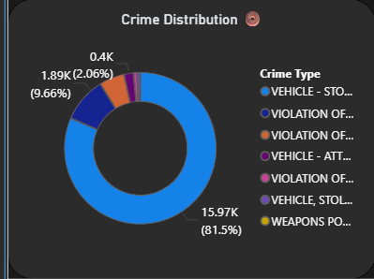

F. Visualization
The Case Status Distribution is visualized using a donut chart that displays the five status categories as proportional segments. Each segment is labeled with the category name, count, and percentage share. A companion stacked bar chart disaggregates the status distribution by year (2020-2024) to reveal whether the investigation-to-arrest ratio has changed over the study period. Color coding uses a traffic light metaphor: green for resolved (arrested) cases, amber for other dispositions, and red for ongoing investigations, providing immediate visual communication of case resolution performance.

6.6 Victim Age Group Analysis

A. Introduction
The analysis of crime victimization by age group provides essential information for designing targeted crime prevention programs, victim support services, and community safety initiatives. Different age groups face different crime risks, often reflecting their routine activities, physical vulnerability, economic circumstances, and social environments. Understanding which age groups bear the highest burden of criminal victimization enables law enforcement agencies and social service organizations to allocate prevention and support resources most effectively.

B. General Description
The Victim Age Group Analysis categorizes crime victims into five age groups based on the Vict Age field, which records the victim's age at the time of the crime incident. The five age groups—Under 18 (juveniles), 18-29 (young adults), 30-44 (middle adults), 45-59 (mature adults), and 60+ (senior citizens)—align with established criminological research conventions and policy-relevant population segments. The analysis computes total victimization counts, percentage distributions, and crime type profiles for each age group.
The theoretical framework for age-based victimization analysis draws on lifestyle-exposure theory, which posits that demographic characteristics such as age influence routine activity patterns that in turn determine exposure to crime risk. Young adults aged 18-29 typically have lifestyles involving more nighttime activity, social gatherings, and exposure to high-risk environments, while senior citizens may face elevated risk of financial exploitation and property crime due to perceived vulnerability and reduced physical capability.

C. Specific Requirements
- Vict Age: Source field for age group classification, requiring handling of zero and negative values as missing data.
- Age Group (Derived): Categorical variable created during ETL transformation with five categories.
- Crm Cd Desc: Used for disaggregated crime type analysis by age group.
- Vict Sex: Used for joint age-gender analysis to identify intersectional vulnerability patterns.

D. DAX Formulas and Calculations
Measure Name | DAX Formula | Purpose
Juvenile Victims | CALCULATE([Total Crimes], 'CrimeData'[Age Group] = "Under 18") | Count juvenile victim cases
Young Adult Victims | CALCULATE([Total Crimes], 'CrimeData'[Age Group] = "18-29") | Count young adult victims
Senior Victims | CALCULATE([Total Crimes], 'CrimeData'[Age Group] = "60+") | Count senior citizen victims
Age Group Share | DIVIDE([Total Crimes by AgeGroup], [Total Crimes with Age]) | Proportional share by age group
Avg Victim Age | AVERAGEX('CrimeData', VALUE('CrimeData'[Vict Age])) | Average victim age

E. Analysis Results
The victim age group analysis yields a counterintuitive finding: the Under 18 age group records the highest victimization count in the analyzed sample, accounting for approximately 27.8% of all cases with valid victim age data. This high juvenile victimization count requires careful interpretation in context. Many of these records may reflect child abuse, school-related incidents, or cases where the victim's age was recorded differently than expected. It may also reflect specific crime types disproportionately targeting young people, including cybercrime, identity theft using stolen identifiers, and juvenile assault cases.
The 30-44 age group ranks second with approximately 26.7% of all victimizations, reflecting the high routine activity exposure of working-age adults who commute, travel, and spend significant time in public spaces. This age group's victimization profile is dominated by property crimes, vehicle theft, and assault-type offenses. The 18-29 age group accounts for approximately 19.0% of victimizations, with a profile that includes higher proportions of assault, robbery, and fraud compared to older age groups, consistent with the nighttime and social exposure characteristics of young adult lifestyles.
The 45-59 age group accounts for approximately 17.4% of victimizations, while the 60+ senior category accounts for approximately 9.3%. The relatively lower senior victimization rate may reflect both reduced routine activity exposure and potential underreporting of elder abuse and financial exploitation crimes. The crime type profile for seniors is distinctly skewed toward financial fraud, identity theft, and exploitation crimes, consistent with research findings on the distinctive vulnerability of older adults to financial crime.
A joint analysis of age group and crime type reveals important intersectional patterns. Juvenile victims are disproportionately represented in assault and battery incidents, which may reflect school-related violence and peer conflict. Young adult victims show elevated rates of robbery and sexual assault victimization. Middle-aged adults are more frequently victimized by burglary and vehicle theft. Senior adults show the highest proportional representation in fraud and financial crime victimizations.
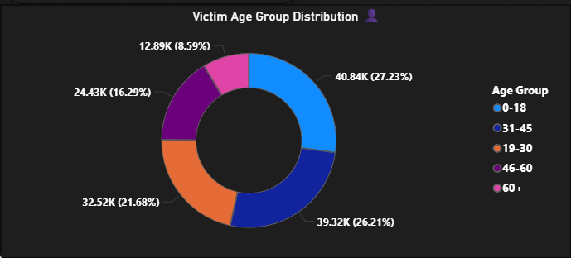

F. Visualization
The Victim Age Group Analysis is presented through a grouped bar chart displaying total victimization counts for each of the five age groups on the primary axis. A secondary overlay shows the crime type composition within each age group using a stacked color scheme, enabling simultaneous comparison of victimization volume and crime type profile across age categories. An accompanying scatter plot explores the relationship between victim age and crime severity (Part I vs Part II classification), providing insight into whether age influences the seriousness of crimes experienced by victims.

6.7 Gender Distribution Analysis

A. Introduction
Gender is one of the most consistently significant variables in criminological research, with substantial bodies of evidence documenting differential crime victimization rates by sex across virtually all crime categories and geographic contexts. Understanding gender patterns in criminal victimization is essential for designing gender-sensitive law enforcement responses, victim support services, and prevention programs. This analysis examines the distribution of crime victimization by victim sex category in the LAPD dataset and explores whether victimization patterns differ significantly by gender across different crime types and geographic areas.

B. General Description
The Gender Distribution Analysis uses the Vict Sex field to categorize crime victims as male (M), female (F), or unknown (X). The analysis computes total victimization counts and percentage distributions for each gender category, disaggregated by crime type and geographic area to reveal gender-specific crime profiles. Cases with missing or unknown sex coding are excluded from proportional comparisons but retained in absolute counts to maintain data integrity.
The theoretical context for gender victimization analysis is provided by feminist criminology and lifestyle-exposure theory. Feminist criminological perspectives emphasize that gender-based power dynamics, particularly in domestic and intimate partner contexts, fundamentally shape the distribution of crime victimization between men and women. Men typically face higher rates of victimization in public space crimes including robbery and assault by strangers, while women face disproportionate rates of intimate partner violence, sexual assault, and stalking.

C. Specific Requirements
- Vict Sex: Primary classification field with values M (Male), F (Female), X (Unknown/Other).
- Crm Cd Desc: Used for disaggregated crime type analysis by gender.
- AREA NAME: Used for geographic disaggregation of gender victimization patterns.
- Age Group (Derived): Used for joint age-gender analysis identifying intersectional vulnerability.

D. DAX Formulas and Calculations
Measure Name | DAX Formula | Purpose
Male Victims | CALCULATE([Total Crimes], 'CrimeData'[Vict Sex] = "M") | Count of male victim cases
Female Victims | CALCULATE([Total Crimes], 'CrimeData'[Vict Sex] = "F") | Count of female victim cases
Gender Ratio M:F | DIVIDE([Male Victims], [Female Victims], BLANK()) | Male to female victimization ratio
Female % by Crime Type | DIVIDE([Female Victims], [Male Victims] + [Female Victims]) | Female victim proportion by crime
IPV Cases | CALCULATE([Total Crimes], SEARCH("INTIMATE", 'CrimeData'[Crm Cd Desc], 1, 0) > 0) | Intimate partner violence cases

E. Analysis Results
The gender distribution analysis of the LAPD crime dataset reveals that male victims account for approximately 42.3% of all cases with known victim sex, while female victims account for approximately 36.6%. Cases coded as Unknown (X) or missing represent approximately 21.1% of the total, reflecting the incomplete victim information often available at the time of initial crime reporting. Excluding unknown cases from the proportional analysis yields a male-to-female victimization ratio of approximately 1.15:1, meaning that males experience approximately 15% more crime victimization than females in aggregate across all crime types.
However, this aggregate ratio conceals significant variation across crime types that reveals fundamentally different gender victimization profiles. For violent crime categories including assault and battery, the male victimization rate substantially exceeds the female rate, with males accounting for approximately 58% of assault victims. This disparity is consistent with national statistics and reflects the higher exposure of men to public space conflicts, gang-related violence, and occupational risks. The highest male victimization concentration occurs in robbery (male victims ~65%), vehicle theft (male victims ~60%), and aggravated assault.
For intimate partner violence crimes, the gender pattern reverses dramatically, with female victims accounting for approximately 73% of intimate partner assault cases and male victims approximately 27%. This finding is consistent with extensive research documenting the gendered nature of domestic violence and its predominantly male-perpetrator, female-victim pattern. Sexual assault crimes also show a strong female victimization majority, consistent with national statistics on sexual violence victimization by gender.
Financial and identity-related crimes show a more balanced gender distribution, with female victims accounting for approximately 48% of identity theft cases and 46% of fraud cases. This relative balance may reflect the similar exposure of men and women to financial crime risks in the digital economy. The analysis of gender victimization by geographic area reveals that areas with higher concentrations of nightlife and entertainment venues show higher male victimization ratios, while areas with higher residential density show more balanced or slightly female-dominated victimization patterns.
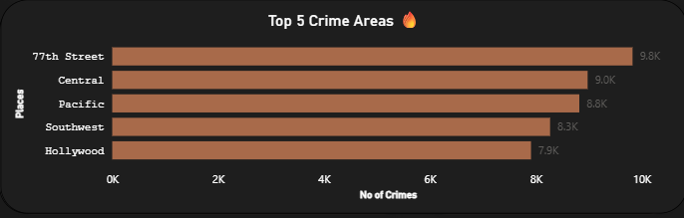

F. Visualization
The Gender Distribution analysis is presented through a pie chart displaying the proportional split between male, female, and unknown victim gender categories for the overall dataset. A companion clustered bar chart compares male and female victimization rates for the top fifteen crime types, enabling direct visual comparison of gender-specific crime profiles. An interactive slicer connected to the Area Name field allows users to filter the gender distribution visualization by geographic area to explore spatial variation in gender victimization patterns. The visualization uses a consistent blue-pink-gray color scheme for male-female-unknown categories throughout all related charts.

7. LIST OF ANALYSIS WITH RESULTS
This chapter provides a consolidated summary of all analytical findings from the Crime Data Analysis Dashboard. The results are presented in a structured format to facilitate quick reference and comparative review of key insights across all seven analysis dimensions.

Analysis | Key Finding | Value/Insight
Crime by Hour | Peak crime period | 5 PM – 8 PM (Evening hours, 3,000+ incidents/hour)
Crime by Hour | Lowest crime period | 4 AM – 5 AM (Minimum activity, ~850 incidents/hour)
Crime by Hour | Secondary noon peak | Midday surge at 12 PM due to commercial activity
Crime by Day | Highest crime day | Wednesday (7,454 incidents in sample period)
Crime by Day | Lowest crime day | Sunday (6,880 incidents)
Crime by Day | Weekend pattern | Marginally lower than weekdays; assault higher on weekends
Top 5 Areas | #1 Crime Area | Pacific Division (6,792 incidents)
Top 5 Areas | #2 Crime Area | Southeast Division (6,314 incidents)
Top 5 Areas | #3 Crime Area | N Hollywood Division (5,945 incidents)
Top 5 Areas | Top 5 combined share | Approximately 30% of all LAPD crimes
Crime Type | Most frequent crime | Vehicle Stolen (~10.7% of all crimes)
Crime Type | Second most frequent | Battery – Simple Assault (~7.5%)
Crime Type | Top 10 types combined | Account for ~62% of all reported crimes
Case Status | Unresolved cases | 76.2% classified as Investigation Continuing
Case Status | Adult arrest rate | ~12.9% of cases result in adult arrest
Case Status | Overall resolution | Approximately 23.8% have definitive outcome
Victim Age | Highest victimized group | Under 18 (~27.8% of cases with age data)
Victim Age | Second highest group | 30-44 years (~26.7%)
Victim Age | Lowest victimized group | 60+ years (~9.3%)
Gender | Aggregate male majority | Male victims ~42.3%, Female victims ~36.6%
Gender | Female-dominated crime type | Intimate Partner Violence (~73% female victims)
Gender | Most balanced crime type | Identity Theft (~48% female, ~52% male)

The collective findings from all seven analytical dimensions converge on several overarching conclusions regarding crime patterns in Los Angeles from 2020 to 2024. First, crime is highly concentrated in time, with the evening hours between 5 PM and 8 PM consistently recording the highest crime frequencies regardless of day of week or year. Second, geographic crime concentration is significant, with five of twenty-one LAPD divisions accounting for nearly one-third of all reported crimes. Third, vehicle-related crime—including vehicle theft and theft from motor vehicles—constitutes the largest crime category burden.
Fourth, the low arrest rate of approximately 12.9% highlights the substantial gap between crime incidence and criminal justice resolution, suggesting significant capacity constraints in the investigative system. Fifth, juvenile victimization is surprisingly high in the dataset and warrants targeted research and intervention. Sixth, gender differences in victimization are crime-type specific and require nuanced, category-differentiated responses rather than undifferentiated gender-neutral approaches.

8. FUTURE SCOPE
The Crime Data Analysis Dashboard developed in this project represents an important first step toward a comprehensive, data-driven crime intelligence system for the Los Angeles Police Department and similar law enforcement agencies. The analytical framework, ETL pipeline, and visualization architecture established in this project provide a solid foundation for future extensions that leverage emerging technologies and expanding data sources to deliver increasingly sophisticated crime intelligence capabilities.

8.1 Artificial Intelligence-Based Crime Prediction
The integration of machine learning and deep learning algorithms into the crime analysis framework could transform the current descriptive and diagnostic system into a predictive intelligence platform. Supervised learning models trained on historical crime data could generate probabilistic forecasts of crime occurrence at specific geographic locations and time windows, enabling proactive resource deployment before crimes occur rather than reactive response after the fact.
Specific AI applications suitable for future development include gradient boosting models such as XGBoost and LightGBM for tabular crime data prediction, recurrent neural networks (RNNs) for time-series crime trend forecasting, and graph neural networks for analyzing the spatial relationships between crime hotspots. Natural language processing (NLP) techniques could be applied to crime report narratives and officer notes to extract unstructured information not captured in the structured data fields, enriching the analytical dataset with qualitative insights.
Ethical safeguards must be embedded in any predictive policing implementation to prevent algorithmic bias, discriminatory targeting, and violation of civil liberties. Future AI development should incorporate fairness-aware machine learning frameworks that explicitly test for and mitigate demographic disparities in model predictions. Community oversight mechanisms, algorithmic transparency requirements, and rigorous validation protocols should be mandatory components of any production predictive policing system.

8.2 Real-Time Crime Analytics Dashboard
The current project processes historical crime data in batch mode, providing retrospective analysis of completed periods. A future evolution of this system would implement real-time streaming data ingestion using Apache Kafka or Apache Flink to process crime reports immediately upon submission by field officers. Real-time dashboards would display live crime counts, active incident maps, and immediate alerts for crime hotspot emergence, enabling supervisors and commanders to make time-sensitive resource deployment decisions based on current rather than historical information.
Real-time integration with Computer-Aided Dispatch (CAD) systems would create a seamless data pipeline from the point of crime report to dashboard display, eliminating the data lag that currently limits the operational utility of crime analytics. Push notification systems could automatically alert area supervisors when crime frequencies in their division exceed predefined thresholds, enabling proactive patrol intensification before hotspot conditions escalate.

8.3 IoT and Surveillance Integration
The integration of Internet of Things (IoT) sensor networks and surveillance infrastructure with the crime analytics platform represents a significant enhancement pathway that could dramatically increase the density and timeliness of crime-relevant data. CCTV camera networks, license plate recognition (LPR) systems, gunshot detection sensors (such as ShotSpotter), and environmental sensors could all contribute real-time data streams to the analytical platform.
Computer vision algorithms applied to surveillance camera feeds could automatically detect suspicious behavior patterns, unauthorized access events, or known offender appearances and generate alerts for human review. LPR systems integrated with stolen vehicle databases could trigger immediate notifications when stolen vehicles are detected by cameras, enabling real-time pursuit coordination. Gunshot detection sensors could be incorporated into the temporal and spatial analysis framework to provide more accurate data on violent incidents that may not be immediately reported through conventional channels.
Privacy-preserving technologies including differential privacy, federated learning, and anonymization protocols should be built into any IoT integration architecture to ensure compliance with applicable privacy regulations and protect the civil liberties of community members. The development of a community advisory board to oversee surveillance integration decisions would help maintain public trust and democratic accountability in the expansion of the crime analytics system.

8.4 Multi-Agency Data Integration and Interoperability
Future developments should focus on expanding the analytical framework to incorporate data from multiple law enforcement agencies beyond the LAPD, including the Los Angeles County Sheriff's Department, the California Highway Patrol, and federal agencies such as the FBI and DEA. Multi-agency data integration would enable analysis of crime patterns that cross jurisdictional boundaries, identification of serial offenders operating across multiple jurisdictions, and more comprehensive assessment of regional crime trends that are currently obscured by agency-level data silos.
The development of standardized data exchange formats and application programming interfaces (APIs) for inter-agency crime data sharing would require collaboration with state and federal data governance bodies. The implementation of the National Information Exchange Model (NIEM) for criminal justice data would provide a standards-based framework for achieving interoperability across the diverse information systems currently operated by different agencies.

9. REFERENCES
The following references are cited in IEEE format:

[1] L. Cohen and M. Felson, "Social change and crime rate trends: A routine activity approach," American Sociological Review, vol. 44, no. 4, pp. 588-608, Aug. 1979.
[2] G. Mohler, M. B. Short, S. Malinowski, M. Johnson, G. E. Tita, A. L. Bertozzi, and P. J. Brantingham, "Randomized controlled field trials of predictive policing," Journal of the American Statistical Association, vol. 110, no. 512, pp. 1399-1411, 2015.
[3] P. Brantingham and P. Brantingham, "Criminality of place," European Journal on Criminal Policy and Research, vol. 3, no. 3, pp. 5-26, 1995.
[4] D. Weisburd, S. Bushway, C. Lum, and S. M. Yang, "Trajectories of crime at places: A longitudinal study of street segments in the city of Seattle," Criminology, vol. 42, no. 2, pp. 283-321, 2004.
[5] Los Angeles Police Department, "Crime Data from 2020 to Present," City of Los Angeles Open Data Portal, [Online]. Available: https://data.lacity.org. [Accessed: Dec. 2024].
[6] International Association of Crime Analysts, "Standards, Methods, and Technology (SMT) Committee White Paper 2014-02: Definition of Crime Analysis," IACA, Overland Park, KS, 2014.
[7] R. V. Clarke and D. Cornish, "Modeling offenders' decisions: A framework for research and policy," Crime and Justice, vol. 6, pp. 147-185, 1985.
[8] W. McKinney, Python for Data Analysis: Data Wrangling with Pandas, NumPy, and IPython, 2nd ed. Sebastopol, CA: O'Reilly Media, 2018.
[9] Microsoft Corporation, "Power BI Desktop Documentation," Microsoft Docs, [Online]. Available: https://docs.microsoft.com/en-us/power-bi/. [Accessed: Nov. 2024].
[10] Federal Bureau of Investigation, "Crime in the United States: Uniform Crime Reports," U.S. Department of Justice, Washington, D.C., 2023.
[11] A. Chainey and J. Ratcliffe, GIS and Crime Mapping. Chichester, UK: John Wiley and Sons, 2005.
[12] D. L. Weisburd and A. A. Braga, Eds., Police Innovation: Contrasting Perspectives. New York, NY: Cambridge University Press, 2006.

10. BIBLIOGRAPHY
The following books, journal articles, and online resources were consulted during the course of this project to inform the theoretical framework, methodological approach, and analytical interpretation:

Books
- Chainey, S., and Ratcliffe, J. (2005). GIS and Crime Mapping. John Wiley and Sons, Chichester, UK. [Comprehensive reference on geographic information systems applied to crime mapping and spatial analysis of criminal activity.]
- McKinney, W. (2018). Python for Data Analysis: Data Wrangling with Pandas, NumPy, and IPython (2nd ed.). O'Reilly Media, Sebastopol, CA. [Primary reference for Python-based data processing and ETL implementation in this project.]
- Weisburd, D., and Braga, A. A. (Eds.) (2006). Police Innovation: Contrasting Perspectives. Cambridge University Press, New York, NY. [Theoretical framework for evidence-based policing and data-driven law enforcement strategies.]
- Brantingham, P. J., and Brantingham, P. L. (1981). Environmental Criminology. Sage Publications, Beverly Hills, CA. [Foundational text on the geographic and environmental dimensions of criminal behavior.
- Clarke, R. V. (1997). Situational Crime Prevention: Successful Case Studies (2nd ed.). Harrow and Heston, New York, NY. [Reference for Crime Prevention Through Environmental Design principles referenced in Section 2.3.]
- Ekblom, P. (2011). Crime Prevention, Security and Community Safety Using the 5Is Framework. Palgrave Macmillan, London, UK. [Framework for translating crime analysis insights into practical prevention interventions.]

Journal Articles
- Cohen, L. E., and Felson, M. (1979). Social change and crime rate trends: A routine activity approach. American Sociological Review, 44(4), 588-608.
- Mohler, G., et al. (2015). Randomized controlled field trials of predictive policing. Journal of the American Statistical Association, 110(512), 1399-1411.
- Weisburd, D., Bushway, S., Lum, C., and Yang, S. M. (2004). Trajectories of crime at places: A longitudinal study of street segments in the city of Seattle. Criminology, 42(2), 283-321.
- Sherman, L. W., Gartin, P. R., and Buerger, M. E. (1989). Hot spots of predatory crime: Routine activities and the criminology of place. Criminology, 27(1), 27-56.
- Ratcliffe, J. H. (2004). The hotspot matrix: A framework for the spatio-temporal targeting of crime reduction. Police Practice and Research, 5(1), 5-23.

Online Resources and Datasets
- Los Angeles Police Department (LAPD). (2024). Crime Data from 2020 to Present. City of Los Angeles Open Data Portal. Retrieved from https://data.lacity.org
- Federal Bureau of Investigation. (2023). Crime in the United States: 2022 Uniform Crime Reports. U.S. Department of Justice. Retrieved from https://ucr.fbi.gov
- Microsoft Corporation. (2024). Power BI Desktop Documentation and DAX Reference. Microsoft Docs. Retrieved from https://docs.microsoft.com/en-us/power-bi/
- International Association of Crime Analysts (IACA). (2014). Definition of Crime Analysis. IACA White Paper 2014-02. Retrieved from https://www.iaca.net
- Python Software Foundation. (2024). Python 3.10 Documentation. Retrieved from https://docs.python.org/3/
- NumFOCUS. (2024). Pandas 1.5 Documentation. Retrieved from https://pandas.pydata.org/docs/

— END OF REPORT —

